1. **Project Management Plan**

Project Management Plan Version 1.0

Date: 05/23/2020

**Project Name:** Getaway Groceries-Online Grocery Store

**Introduction/Overview of Project:**

To develop web application for creating a user friendly eCommerce website where customers are able to purchase and check out their products easily without any trouble and getting stuck in any process starting from placing the order till the order getting placed confirmation.

Evolution of this website:

There are several stages and modifications in the project from start to finish. The changes are well documented in Microsoft Office and Google Documents, so they can be viewed and worked simultaneously by all of the team members. All the proposals for improvements are officially submitted by a team member to build a user profile and the project manager 's commission is set up to agree on the changes. The main purpose of Google Docs is to save these changes as formally noted as the requests for changes continue to appear.

**Project Organization:**

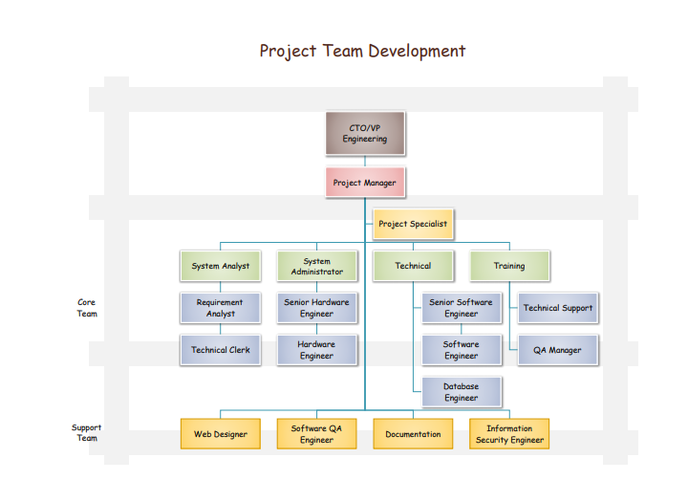

**Management and Technical Processes**

**Management Processes**:

**Management Objectives and Priorities:**

The top most priority of the Management is ensuring that the product is delivered within the time and budget and is functioning properly without any glitches.

Once a new proposal comes up, the management committee decides whether a change needs to be accepted or not.

**Assumptions, Dependencies, and Constraints:**

The project should always satisfy the triple constraints scope, quality and time.

**Risk Management:**

When some risk occurs in our project first, the root cause is identified and the root cause is minimized by the risk management techniques which are needed and is typically managed by the risk management department.

**Monitoring and Controlling Mechanisms:**

Monitoring and Controlling systems are very important and play a very important role in a project, as these mechanisms will allow us to verify the outcomes of the projects are properly evaluated. When there are any issues or significant changes, these mechanisms will identify and monitor the issues throughout the project.

**Staffing Plan:**

The Project mainly requires a project manager, program manager, database analyst, programmers, test engineers, and other staff which are to be highly skilled with good professional behavior and proper soft skills.

**Technical Processes:**

**Methods, Tools, and Techniques:**

Microsoft Excel, HTML, Bootstrap MD, React, JavaScript, Node Js, Microsoft Office, JIRA.

**Software Documentation:**

Documentation is the main part of Software Engineering Process. Software designed by the each individual must be neatly presented so the every individual can understand how the software functions and what requirements should be followed when designing a program.

**Project Support Functions:**

While we adopt the Agile Methodology, the scrum master will also organize scrum meetings to monitor the progress of every task assigned to each project member and whether there are any changes in the current process.

Project Manager will be monitoring the application performance and addresses the changes in the project Life cycle.

**Work to Be Performed**

A work package is the lowest component of the WBS, sometimes referred to as the terminal element of a WBS structure. If you decompose a deliverable into component while creating a work breakdown structure, you create a working package. All factors, such as a budget, material(s), personnel, timetable, milestone and the best technology to use, will be included.

**Schedule Information**

The project has been started on 05/12/2020 and will end on 06/04/2020. The project time management plan has a detailed schedule of the project.

**Budget Information**

The estimated budget of the project is $ $267,971. Based on the Project Team, Resources required for developing a project, technologies used the project Manager will allocate all those resources accordingly.

**References to Other Project Planning Documents:**

A Guide to the Project Management Body of Knowledge (PMBOK Guide) 2000 edition - Project Management Institute.

We have referred to many documents and done a thorough study on how it can be useful to our project Online Grocery store Website. After going through all the articles we have chosen the above as reference and thought it would serve better for our project Management.